**Pranav Assessment – Data Analyst Intern**

**Q1 : - What is the typical engagement rate we can expect? What’s the likelihood that we can**

**achieve a 15% engagement rate?**

**Ans :- Typical Engagement Rate: 4.20%**

**Likelihood of Achieving 15% Engagement Rate:** **6.42%**

**Q2: - Does day of the week and time of posting affect engagement rates?**

**Ans: -** 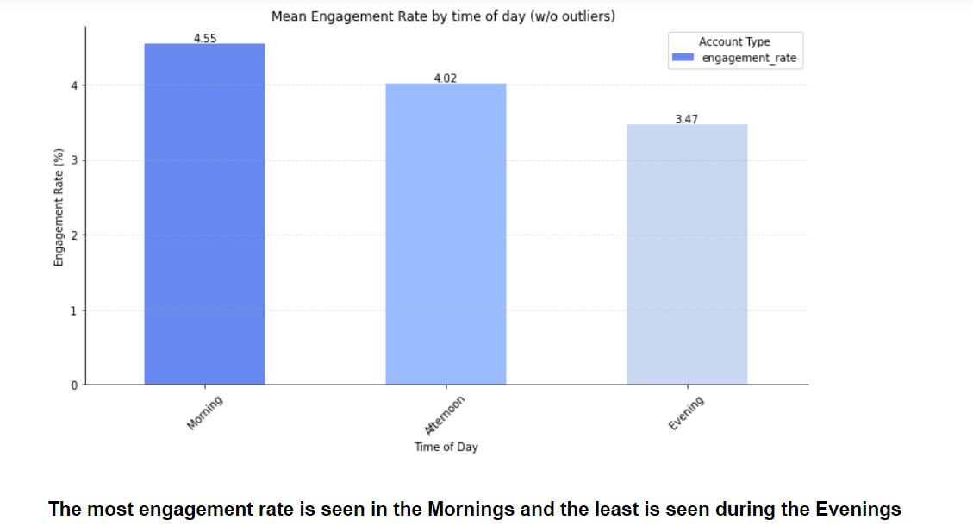

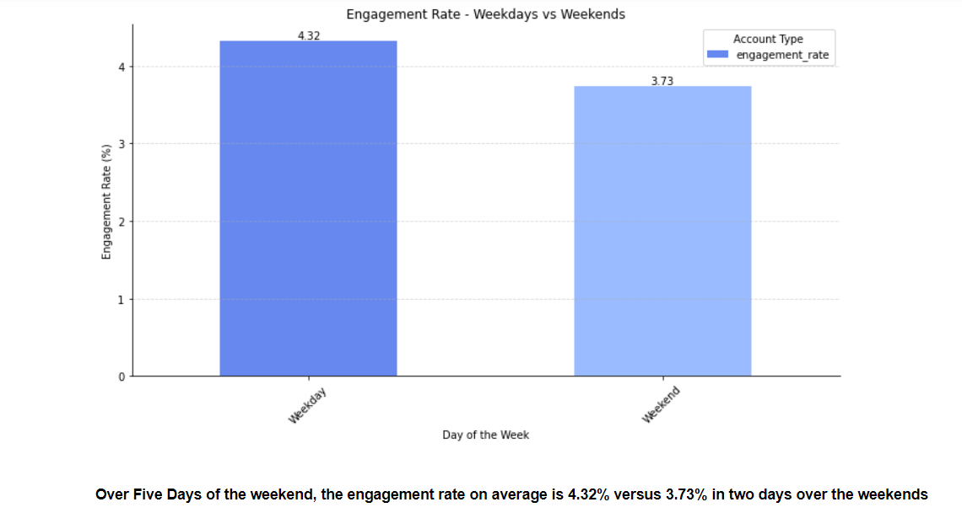

**The engagement is mornings and during the weekends.**

**Q3: - How are our game titles doing in terms of social performance? Is there a specific game we should focus more on or less?**

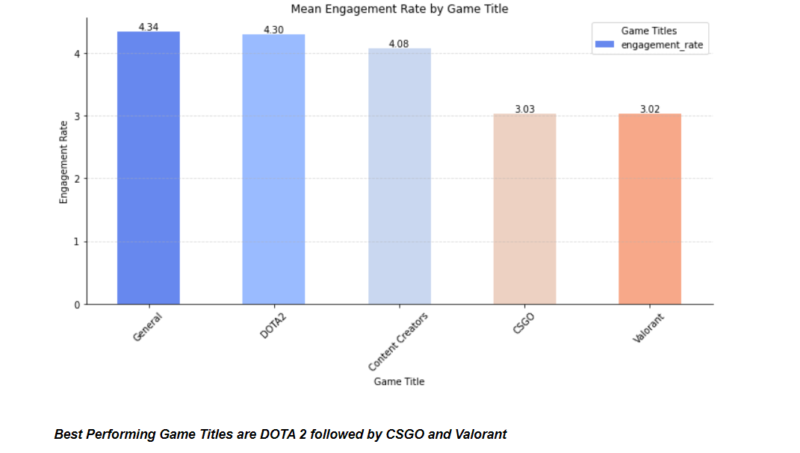

**We should focus more on valorant as it is a relatively newer game in the market and is highly popular while also maximizing DOTA 2 social media engagement as it is the best performing one. While CSGO remains evergreen, it has been on a slight decline in recent times.**

**Q4: - What media type performs the best?**

**Ans: -** 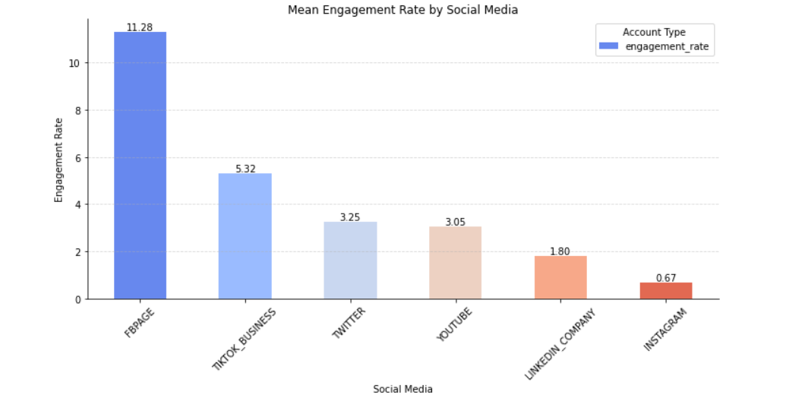

**Facebook, Tiktok and Twitter are the best performing social media types.**

**Q5: - What is our best performing campaign?**

**Ans: -**

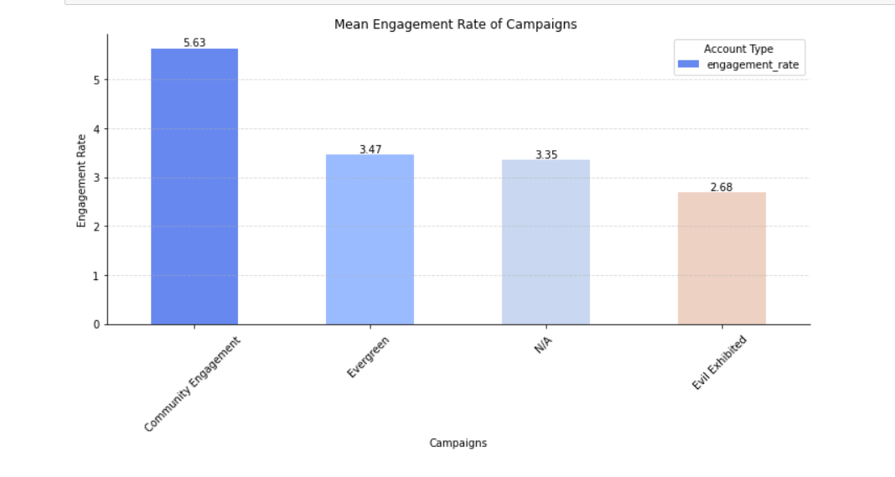

**Community Engagement is the best performing campaign while Evil Exhibited can be improved**

**Q6: - Define out a posting strategy for our social channels based on your discoveries.**

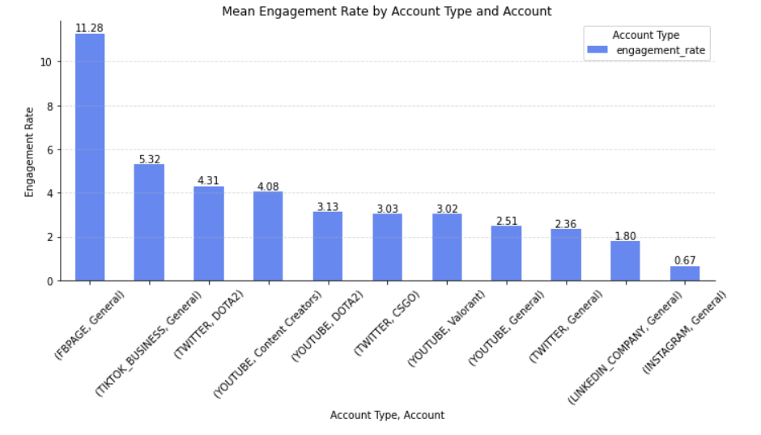**Ans: -**

**Our Facebook and TikTok Businesses are going extremely well and in those two platforms, we can maximize out posting whilst also ramping up posting on Youtube since people are eager to learn more about teams and their playstyles on youtube, especially tricks that pros use while gaming.**

**Q7 - 7. What suggestions would you give to the social media team if they want to expand their presence (e.g. if our CSGO youtube channel is doing well should we expand to TikTok)?**

**Ans : -**

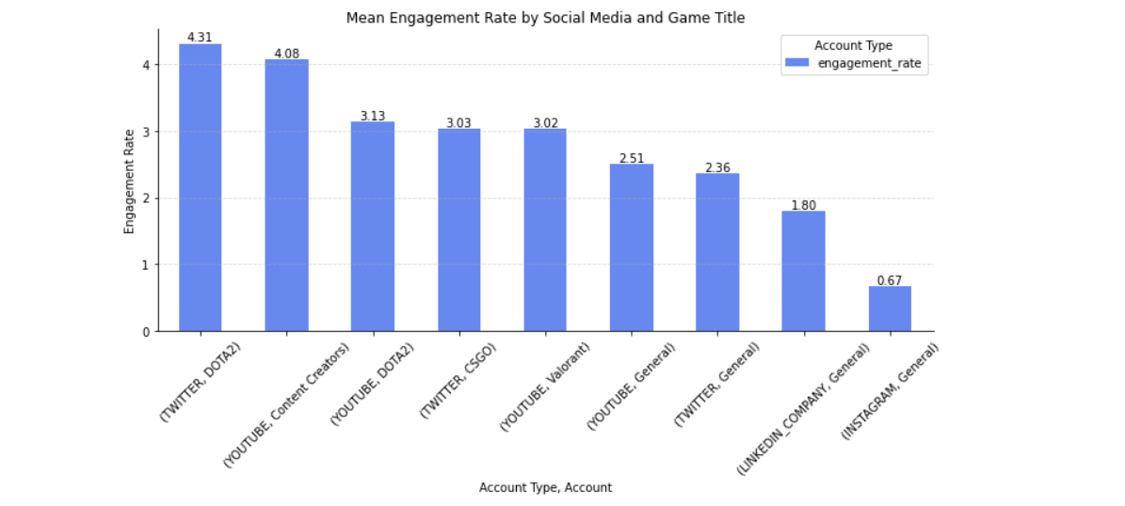

**The maximum engagements are seen in Facebook and Tiktok from the given dataset so it makes sense to ramp up postings on these two platform for all the game titles of CSGO, Dota2, Valorant to name a few. Expanding to other platforms will increase the likelihood of more reach based on the above graph findings.**